OS
PRACTICAL 1
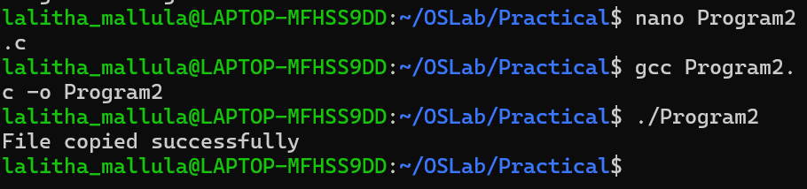
PRACTICAL 2
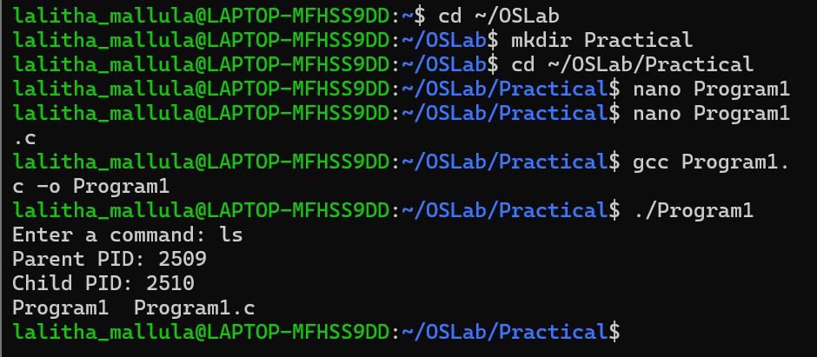
PRACTICAL 3
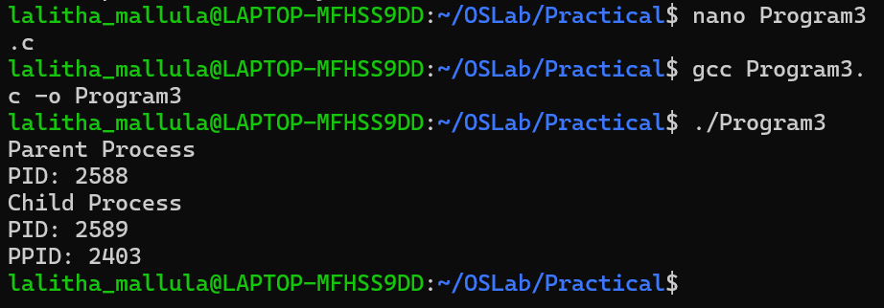

PRACTICAL 4
